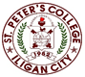

***Committed to Excellence***

St. Peter’s College

042 Sabayle St., Iligan City

**COLLEGE OF COMPUTER STUDIES (SEMINAR AND TOURS)**

**NARRATIVE REPORT ON SEMINAR (MOBILE APPLICATION DEV)**

On the afternoon of April 26, 2024, at around 1:30 pm, the 2nd to 4th-year students gathered in the computer laboratory, Room A202, at St. Peter’s College for a seminar by Mr. Gabriel Casino. The seminar began around 2:00 pm with a prayer, followed by the national anthem and the Opening Program.

Mr. Casino discussed Mobile Application Development using React.js, highlighting its current demand in the job market, its usefulness, and its ease of understanding. He also gave a brief introduction about himself, including his background and alma mater.

Following the discussion, he demonstrated the basic functions of React.js, explaining its syntax and functionality. After the demonstration, he presented us with a problem to solve using the knowledge we had gained from his discussion. Once we solved the problem, we asked Mr. Gabriel various questions regarding the React framework. After the Q&A session, we took pictures with him as the seminar concluded.

Prepared by:

Edward Jr A. Cabello

       Student

Checked by:

MELLANIE S. GAMBE, MSIT

Dean, College of Computer Studies

Reviewed & Approved by:

MELLANIE S. GAMBE, MSIT

Dean, College of Computer Studies

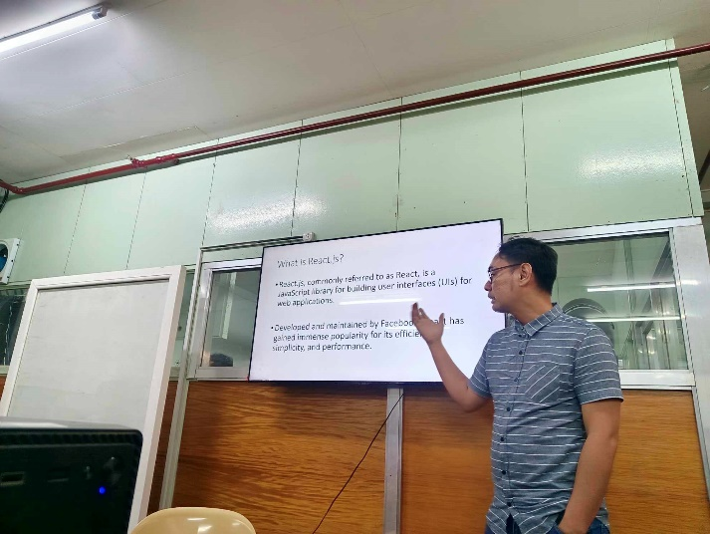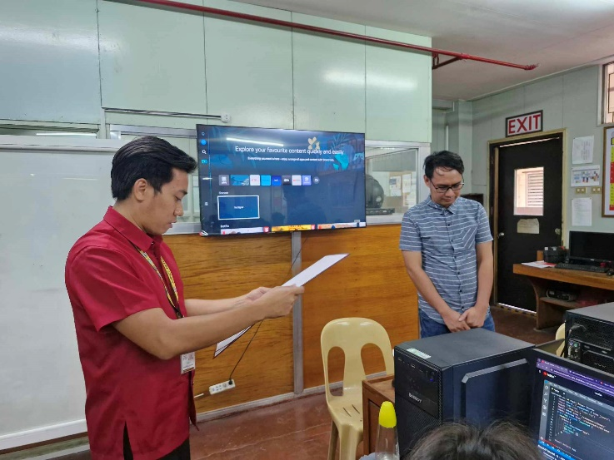

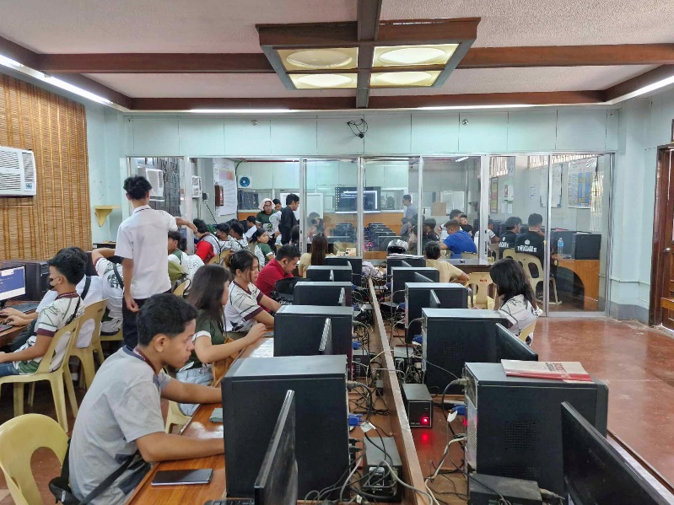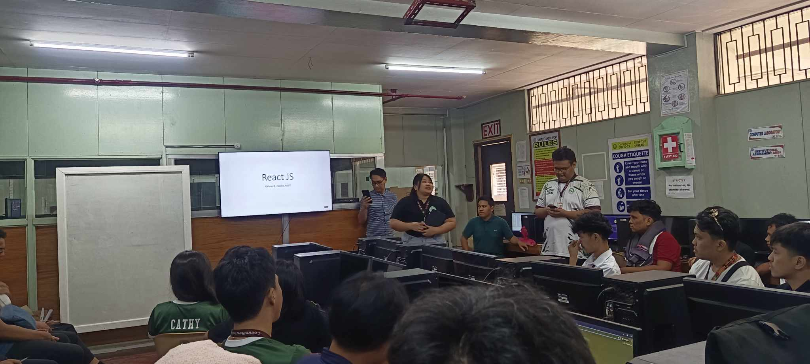

Upper-Left: Giving certificate to speaker Mr. Gabriel.

Upper-Right: Mr, Gabriel explains React.js Framework.

Lower-Left: Problem Solving and Coding.

Lower-Right: Opening Program.

.